July 7, 2024
Rain or Shine
Downtown Brainard
Entry: 9:00am-Noon
Show: Noon-4:00pm
Pre-registration: $15.00
Day of Show: $20.00
Please no pets or bicycles
Sponsored by the Brainard Car Club
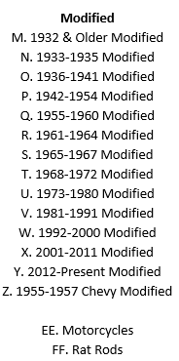
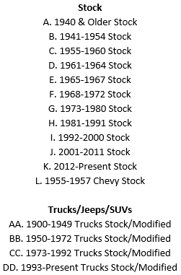

NEW CLASSES!
(subject to change)
Awards Given for Top 3 Places in Each Class
Plus Awards for Specialty Classes

---------------------------------------------------------------------------------------------------------------------------------------
Pre-registration must be received by July 6, 2024

Name___________________________________________________________________ Address___________________________________________ City_________________________ State__________________________ Zip______________________
Year__________ Make____________________ Model_____________________ Class__________
Stock Class = Up to two modifications Modified Class = Three or more modifications

All Vehicles must have Proof of Insurance. By your signature here, the applicant and guest do herby hold harmless the Brainard Car Club, its members, and any participating sponsors from any liability for damage or injury while participating at the said event.

Signature: ______________________________________________________________

Send To: Brainard Car Club, P.O. Box 33, Brainard, NE 68626

For More Information:
www.brainardcarclub.org
brainardcarclub@gmail.com
Tyler: (402) 545-2511

